Advance Excel Assignment 1

1. What do you mean by cells in an excel sheet?

Answer:

**Cells is the intersection of column and rows**.

1. How can you restrict someone from copying a cell from your worksheet?

Answer:

**Step 1.Select the cells then right click and go to format cells >go to protection and lock/unlock accordingly.**

**Step 2.Now right click on workwook tab(below) and click on protect sheet and add password to protect sheet.**

1. How to move or copy the worksheet into another workbook?

Answer:

Note: A workbook(file) contains many worksheets(as sheet1,sheet2 etc)

**To move or copy a worksheet to another wokbook go to the sheet you want to move/copy> to Home > Format(on ribbon) >Select move or copy>Select “To book” option to slect workbook >select its sheet/move to end.**

1. Which key is used as a shortcut for opening a new window document?

**Ctrl+N**

1. What are the things that we can notice after opening the Excel interface?

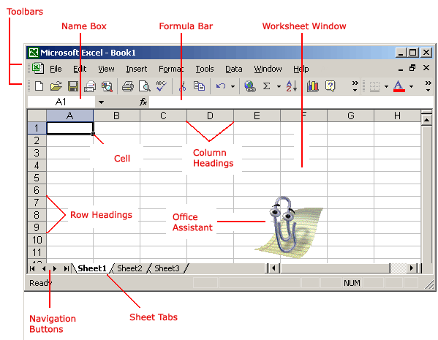

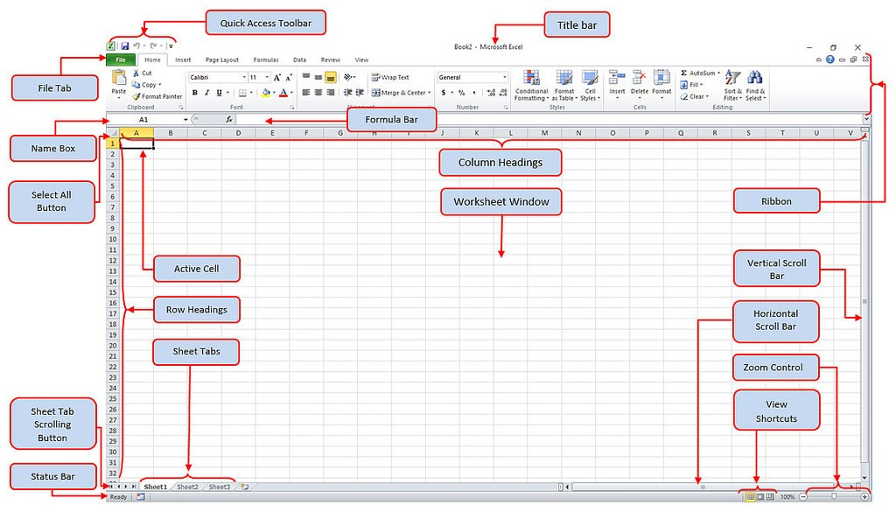

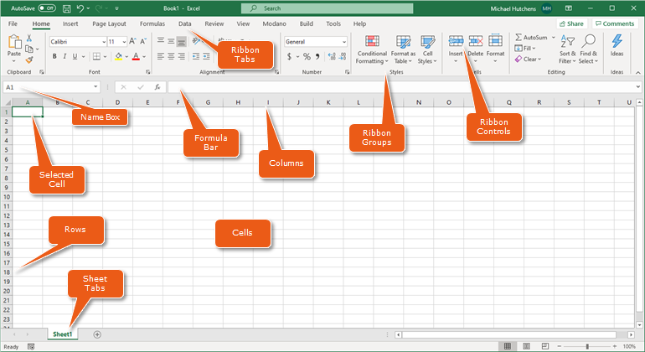

1. When to use a relative cell reference in excel?

**Relative cell reference is used when to use same pattern of fomula to other cells by double click.**

**If you want something fix and not relative in formula we**

**use(F4) to make it absolute as $B$4 thus called as Absolute**

**cell reference.**